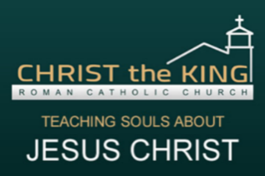
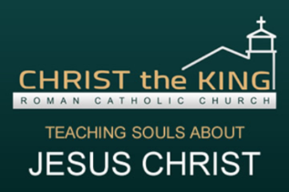
CHRIST THE KING
Confirmation 1 & 2 Class Schedule
2 0 2 0 - 2 0 2 1

January 2021
 | MON 1/4 | Confirmation 1 via ZOOM 6:30 pm
 | WED 1/6 | Confirmation 2 via ZOOM 6:30pm
 | MON 1/18 | Confirmation 1 via ZOOM 6:30 pm
 | WED 1/20 | Confirmation 2 via ZOOM 6:30pm
February 2021
 | MON 2/1 | Confirmation 1 via ZOOM 6:30 pm
 | WED 2/3 | Confirmation 2 via ZOOM 6:30pm
 | MON 2/22 | Confirmation 1 via ZOOM 6:30 pm
 | WED 2/24 | Confirmation 2 via ZOOM 6:30pm
March 2021
 | MON 3/8 | Confirmation 1 via ZOOM 6:30pm
 | WED 3/10 | Confirmation 2 via ZOOM 6:30pm  *Saint/Sponsor Info Due Online for C2
 | MON 3/29 | Confirmation 1 via ZOOM 6:30pm
 | WED 3/31 | Confirmation 2 via ZOOM 6:30pm
April 2021
 | MON 4/12 | Confirmation 1 via ZOOM 6:30pm  *BOOK REPORT DUE
 | WED 4/14 | Confirmation 2 via ZOOM 6:30pm  *BOOK REPORT DUE
 | MON 4/26 | Confirmation 1 via ZOOM 6:30pm
 | WED 4/28 | Confirmation 2 via ZOOM 6:30pm
May 2021
 | MON 5/3 | Confirmation 1 via ZOOM 6:30pm
 | WED 5/5 | Confirmation 2 via ZOOM 6:30pm  *Saint/Sponsor Info Due Online for C1
 | SUN 5/17 | Confirmation 1 via ZOOM 6:30pm
 | WED 5/19 | Confirmation 2 via ZOOM 6:30pm
 | SAT 5/22 | CONFIRMATION MASS 2PM

Contact Suzie Salazar if you have any questions!
661-800-1323
youthministry@christtheking.ws
Visit us on the web at www.christthekingyouth.weebly.com
Find us on Instagram @CTKFEARLESS
Facebook.com/ctkfearless

