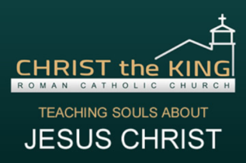
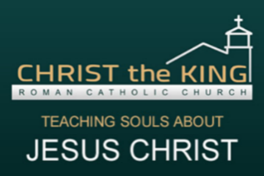
CHRIST THE KING
Religious Education Class Schedule
2 0 2 0 - 2 0 2 1
All Classes are Tuesdays/Wednesdays/Thursdays: 6:00—6:30pm until further notice
At least 1 parent is to remain with their child during class time in 1st and 2nd years.
January 2021
 | TUES 1/5 | CLASS- 1st Communion -group A
 | WED 1/6 | CLASS- 1st Reconciliation
 | THUR 1/7 | CLASS- 1st Communion -group B
 | TUES 1/12 | CLASS- 1st Communion -group A
 | WED 1/13 | CLASS- 1st Reconciliation
 | THUR 1/14 | CLASS- 1st Communion -group B
 | TUES 1/19 | CLASS- 1st Communion -group A
 | WED 1/20 | CLASS- 1st Reconciliation
 | THUR 1/21 | CLASS- 1st Communion -group B
 | TUES 1/26 | CLASS- 1st Communion -group A
 | WED 1/27 | CLASS- 1st Reconciliation
 | THUR 1/28 | CLASS- 1st Communion -group B
February 2021
 | TUES 2/2 | CLASS- 1st Communion -group A
 | WED 2/3 | CLASS- 1st Reconciliation
 | THUR 2/4 | CLASS- 1st Communion- group B
 | TUES 2/9 | CLASS- 1st Communion- group A
 | WED 2/10 | CLASS- 1st Reconciliation
 | THUR 2/11 | CLASS- 1st Communion- group B
 | 2/15-2/19 | NO CLASSES- ASH WEDNESDAY WEEK
 | TUES 2/23 | CLASS- 1st Communion -group A
 | WED 2/24 | CLASS- 1st Reconciliation
 | THUR 2/25 | CLASS- 1st Communion- group B
March 2021
 | TUES 3/2 | CLASS- 1st Communion -group A
 | WED 3/3 | CLASS- 1st Reconciliation
 | THUR 3/4 | CLASS- 1st Communion- group B
 | TUES 3/9 | CLASS- 1st Communion -group A
 | WED 3/10 | CLASS- 1st Reconciliation
 | THUR 3/11 | CLASS- 1st Communion- group B
 | WED 3/17 | CLASS- 1st Reconciliation  ***Confessions for 1st Communion class 6:00PM
 | SAT 3/20 | FIRST COMMUNION MASS- 4PM
 | SUN 3/21 | FIRST COMMUNION MASS- 9:30AM
 | WED 3/24 | Confessions for 1st Reconciliation class 6PM
 | WED 3/31 | CLASS- 1st Reconciliation (Last Class)
Classes will take place via Google Meets, link to the meeting will be posted in Google Classroom. Classes will begin at 6pm.
Contact Suzie Salazar if you have any questions!
661-800-1323
youthministry@christtheking.ws
Visit us on the web at www.christthekingyouth.weebly.com

